System Requirements

Functional Requirements:
In my Automation System for Cargo Program,Administrator only enter the own system with his/her password that is setted by program.In my test program I set the password 1234 for Administrator.Then Branch Employees and Transportation Personel also enter the system with own branch password that is setted by program.In my test program I set the branches’ password with 0000.So If you are Adminstrator then you must enter 1234 to password area and If you are Branch Employee or Transportation Personel then you must enter 0000 to password area becouse I set all branches’ password 0000.If you are Customer then you don’t need to enter password and after that Customer need to enter his/her cargo tracking number then if There is a cargo then program shows the restricted cargo imformation. Administrators can add branches,branch employees and transportation employees and remove them.Branch employees can add cargos and customers and remove cargos and customers and see cargo and customer imformations in that branch.Transportation personel can only update status of cargos.If Branch employees want to record the cargos then should enter add cargo but if Branch Employees want to add only a customer then should enter add customer becouse cargos and customers are different.
If Branch Employees want to see cargos then enter show cargo imformations place and if they want to see customers then enter show customer imformation place.These are my functional system requirements.

Non-Functional Requirements:
Performance,Speed,Capacity

Use Case Diagram
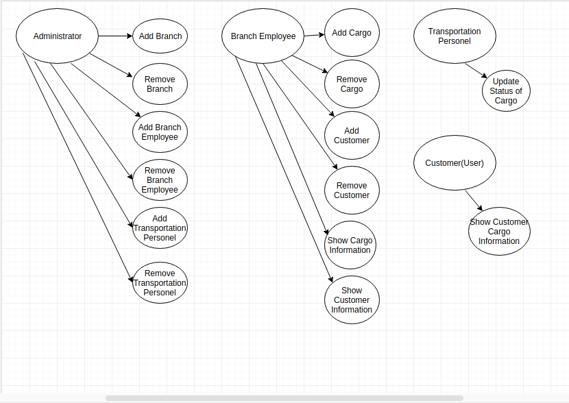
Class Diagram

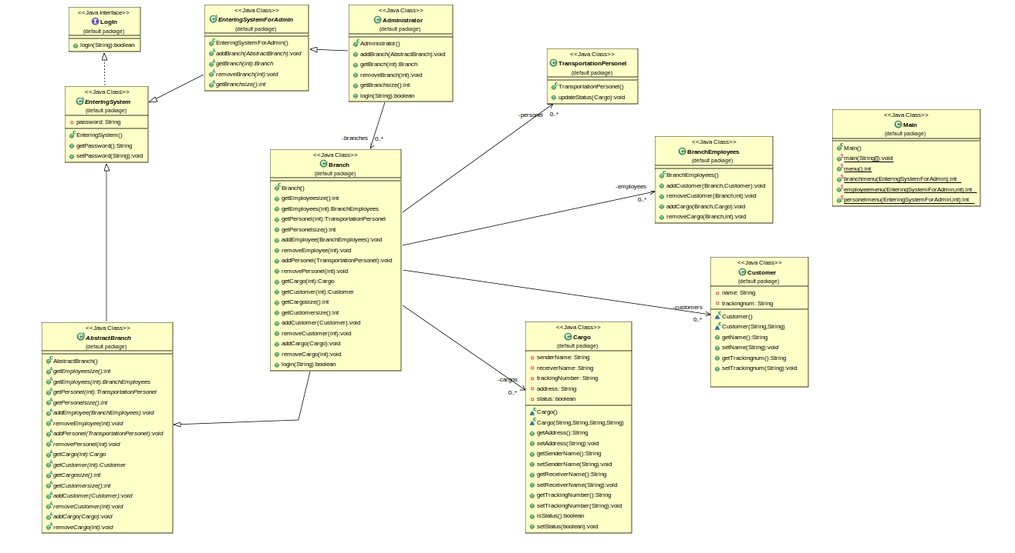
Problem Solution Approach
In this program , I wrote an interface class that is LogIn, three abstract class that are EnteringSystem, EnteringSystemForAdmin, AbstractBranch and seven concrete class that are Administartor,Branch,BranchEmployees,TransportationPersonel,Customer,Cargo,Main.I though that to enter the system there need be password to admisnistrator and branches So I first wrote LogIn interface.Then I wrote EnteringSystem that implements interface LogIn to keep password imformation.After That I wrote abstract classes that are EnteringSystemForAdmin and AbstractBranch that extends the abstract EnteringSystem Class.Finally I wrote concrete classes.
I thought that If Administrator can add and remove branch then it should have branch arraylist.Administrator can add Branch employee and Transportation personel but I put employee and personel arrayslist in branch class becouse every branch has own branch employee and trasportation personel.Also Branch has own cargos and customers arraylists.I thought customers and cargos are different array.I though that Branch Employees record cargos to send them and record customer so that The imfomations about customers stay in branch. As a result , I approach the problem very closely that I wrote.

Test Cases
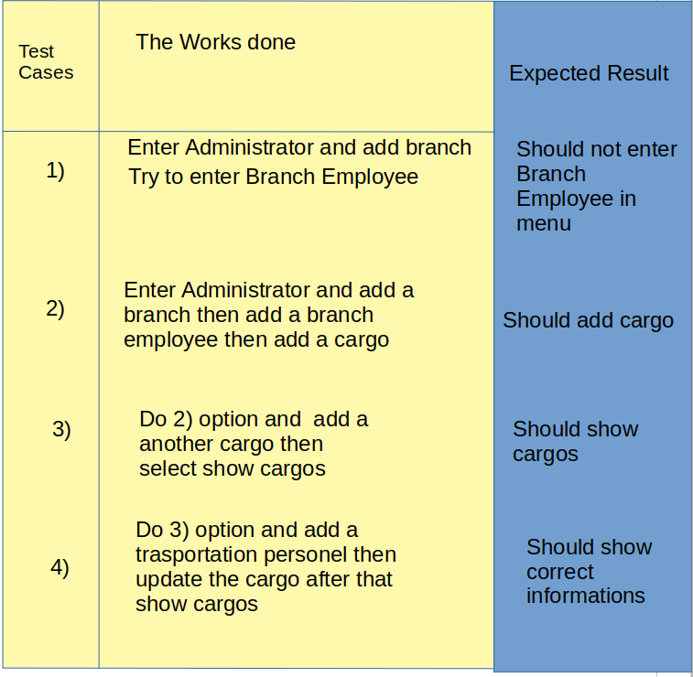

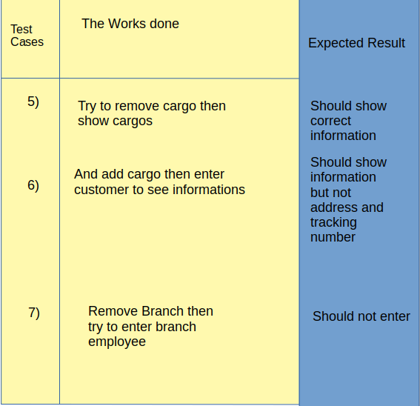

Running Command and Results

Output Case 1)
Welcome Your Automation System
1 : Administrator
2 : Branch Employee
3 : Transportation Personel
4 : Customer
0 : Exit
1
Please enter the password!!
1234
1 : Add Branch
2 : Add Branch Employee
3 : Add Transportation Personel
4 : Remove Branch
5 : Remove Branch Employee
6 : Remove Transportaiton Personel
0 : Back
1
You added Branch
Welcome Your Automation System
1 : Administrator
2 : Branch Employee
3 : Transportation Personel
4 : Customer
0 : Exit
2
Choose one of them
1. Branch
1
Please enter the password!!
0000
There is not any employee please first add a employee by administrator!
Welcome Your Automation System
1 : Administrator
2 : Branch Employee
3 : Transportation Personel
4 : Customer
0 : Exit
0

In Output Case 1 , As we expect, It didn’t enter branch employee becouse Administrator didn’t add branch employee.

Output Case 2)
Welcome Your Automation System
1 : Administrator
2 : Branch Employee
3 : Transportation Personel
4 : Customer
0 : Exit
1
Please enter the password!!
1234
1 : Add Branch
2 : Add Branch Employee
3 : Add Transportation Personel
4 : Remove Branch
5 : Remove Branch Employee
6 : Remove Transportaiton Personel
0 : Back
1
You added Branch
Welcome Your Automation System
1 : Administrator
2 : Branch Employee
3 : Transportation Personel
4 : Customer
0 : Exit
1
Please enter the password!!
1234
1 : Add Branch
2 : Add Branch Employee
3 : Add Transportation Personel
4 : Remove Branch
5 : Remove Branch Employee
6 : Remove Transportaiton Personel
0 : Back
2
Choose one of them
1. Branch
1
You added a branch employee
Welcome Your Automation System
1 : Administrator
2 : Branch Employee
3 : Transportation Personel
4 : Customer
0 : Exit
2
Choose one of them
1. Branch
1
Please enter the password!!
0000
Choose one of them
1.Employee
1
1 : Add Cargo
2 : Add Customer
3 : Remove Cargo
4 : Remove Customer
5 : Show Cargo Imformations
6 : Show Customer Imformation
0 : Back
1
Enter the imformation about cargo orderly
Sender : Mustafa Tokgöz
Receiver : Başak Karakaş
Tracking number : 171044077
Address : İstanbul
Cargo is added
Welcome Your Automation System
1 : Administrator
2 : Branch Employee
3 : Transportation Personel
4 : Customer
0 : Exit

In Output Case 2 , As we expect, It entered branch employee and added a cargo successfully becouse Administrator added branch and branch employee then branch employee add a cargo.

Output Case 3)
Welcome Your Automation System
1 : Administrator
2 : Branch Employee
3 : Transportation Personel
4 : Customer
0 : Exit
1
Please enter the password!!
1234
1 : Add Branch
2 : Add Branch Employee
3 : Add Transportation Personel
4 : Remove Branch
5 : Remove Branch Employee
6 : Remove Transportaiton Personel
0 : Back
1
You added Branch
Welcome Your Automation System
1 : Administrator
2 : Branch Employee
3 : Transportation Personel
4 : Customer
0 : Exit
1
Please enter the password!!
1234
1 : Add Branch
2 : Add Branch Employee
3 : Add Transportation Personel
4 : Remove Branch
5 : Remove Branch Employee
6 : Remove Transportaiton Personel
0 : Back
2
Choose one of them
1. Branch
1
You added a branch employee
Welcome Your Automation System
1 : Administrator
2 : Branch Employee
3 : Transportation Personel
4 : Customer
0 : Exit
2
Choose one of them
1. Branch
1
Please enter the password!!
0000
Choose one of them
1.Employee
1
1 : Add Cargo
2 : Add Customer
3 : Remove Cargo
4 : Remove Customer
5 : Show Cargo Imformations
6 : Show Customer Imformation
0 : Back
1
Enter the imformation about cargo orderly
Sender : Mustafa Tokgöz
Receiver : Başak Karakaş
Tracking number : 171044077
Address : İstanbul
Cargo is added
Welcome Your Automation System
1 : Administrator
2 : Branch Employee
3 : Transportation Personel
4 : Customer
0 : Exit
2
Choose one of them
1. Branch
1
Please enter the password!!
0000
Choose one of them
1.Employee
1
1 : Add Cargo
2 : Add Customer
3 : Remove Cargo
4 : Remove Customer
5 : Show Cargo Imformations
6 : Show Customer Imformation
0 : Back
1
Enter the imformation about cargo orderly
Sender : Başak Karakaş
Receiver : Mustafa Tokgöz
Tracking number : 1111
Address : Gebze
Cargo is added
Welcome Your Automation System
1 : Administrator
2 : Branch Employee
3 : Transportation Personel
4 : Customer
0 : Exit
2
Choose one of them
1. Branch
1
Please enter the password!!
0000
Choose one of them
1.Employee
1
1 : Add Cargo
2 : Add Customer
3 : Remove Cargo
4 : Remove Customer
5 : Show Cargo Imformations
6 : Show Customer Imformation
0 : Back
5
1. Cargo :
Sender : Mustafa Tokgöz
Receiver : Başak Karakaş
Tracking Number : 171044077
Address : İstanbul
Current Status : In 1.Branch
Cargo is here and hasn't delivered yet!!

2. Cargo :
Sender : Başak Karakaş
Receiver : Mustafa Tokgöz
Tracking Number : 1111
Address : Gebze
Current Status : In 1.Branch
Cargo is here and hasn't delivered yet!!

Welcome Your Automation System
1 : Administrator
2 : Branch Employee
3 : Transportation Personel
4 : Customer
0 : Exit
In Output Case 3 , As we expect, It entered add a another cargo then entered show cargos successfully becouse Administrator added branch and branch employee then branch employee add a cargo and another cargo then branch employee entered show cargo imformation.After that program works successfully.

Output Case 4)
Welcome Your Automation System
1 : Administrator
2 : Branch Employee
3 : Transportation Personel
4 : Customer
0 : Exit
1
Please enter the password!!
1234
1 : Add Branch
2 : Add Branch Employee
3 : Add Transportation Personel
4 : Remove Branch
5 : Remove Branch Employee
6 : Remove Transportaiton Personel
0 : Back
1
You added Branch
Welcome Your Automation System
1 : Administrator
2 : Branch Employee
3 : Transportation Personel
4 : Customer
0 : Exit
1
Please enter the password!!
1234
1 : Add Branch
2 : Add Branch Employee
3 : Add Transportation Personel
4 : Remove Branch
5 : Remove Branch Employee
6 : Remove Transportaiton Personel
0 : Back
2
Choose one of them
1. Branch
1
You added a branch employee
Welcome Your Automation System
1 : Administrator
2 : Branch Employee
3 : Transportation Personel
4 : Customer
0 : Exit
2
Choose one of them
1. Branch
1
Please enter the password!!
0000
Choose one of them
1.Employee
1
1 : Add Cargo
2 : Add Customer
3 : Remove Cargo
4 : Remove Customer
5 : Show Cargo Imformations
6 : Show Customer Imformation
0 : Back
1
Enter the imformation about cargo orderly
Sender : Mustafa Tokgöz
Receiver : Başak Karakaş
Tracking number : 171044077
Address : İstanbul
Cargo is added
Welcome Your Automation System
1 : Administrator
2 : Branch Employee
3 : Transportation Personel
4 : Customer
0 : Exit
2
Choose one of them
1. Branch
1
Please enter the password!!
0000
Choose one of them
1.Employee
1
1 : Add Cargo
2 : Add Customer
3 : Remove Cargo
4 : Remove Customer
5 : Show Cargo Imformations
6 : Show Customer Imformation
0 : Back
1
Enter the imformation about cargo orderly
Sender : Başak Karakaş
Receiver : Mustafa Tokgöz
Tracking number : 1111
Address : Gebze
Cargo is added
Welcome Your Automation System
1 : Administrator
2 : Branch Employee
3 : Transportation Personel
4 : Customer
0 : Exit
2
Choose one of them
1. Branch
1
Please enter the password!!
0000
Choose one of them
1.Employee
1
1 : Add Cargo
2 : Add Customer
3 : Remove Cargo
4 : Remove Customer
5 : Show Cargo Imformations
6 : Show Customer Imformation
0 : Back
5
1. Cargo :
Sender : Mustafa Tokgöz
Receiver : Başak Karakaş
Tracking Number : 171044077
Address : İstanbul
Current Status : In 1.Branch
Cargo is here and hasn't delivered yet!!

2. Cargo :
Sender : Başak Karakaş
Receiver : Mustafa Tokgöz
Tracking Number : 1111
Address : Gebze
Current Status : In 1.Branch
Cargo is here and hasn't delivered yet!!

Welcome Your Automation System
1 : Administrator
2 : Branch Employee
3 : Transportation Personel
4 : Customer
0 : Exit
1
Please enter the password!!
1234
1 : Add Branch
2 : Add Branch Employee
3 : Add Transportation Personel
4 : Remove Branch
5 : Remove Branch Employee
6 : Remove Transportaiton Personel
0 : Back
3
Choose one of them
1. Branch
1
You added a transportation personel
Welcome Your Automation System
1 : Administrator
2 : Branch Employee
3 : Transportation Personel
4 : Customer
0 : Exit
3
Choose one of them
1. Branch
1
Please enter the password!!
0000
Choose one of them
1.Personel
1
Choose one of them
1. Cargo
Sender : Mustafa Tokgöz
Receiver : Başak Karakaş
Tracking Number : 171044077
Address : İstanbul
Current Status : In 1.Branch
Cargo is here and hasn't delivered yet!!

2. Cargo
Sender : Başak Karakaş
Receiver : Mustafa Tokgöz
Tracking Number : 1111
Address : Gebze
Current Status : In 1.Branch
Cargo is here and hasn't delivered yet!!

1
You update the cargo and cargo is given to its owner
Welcome Your Automation System
1 : Administrator
2 : Branch Employee
3 : Transportation Personel
4 : Customer
0 : Exit
2
Choose one of them
1. Branch
1
Please enter the password!!
0000
Choose one of them
1.Employee
1
1 : Add Cargo
2 : Add Customer
3 : Remove Cargo
4 : Remove Customer
5 : Show Cargo Imformations
6 : Show Customer Imformation
0 : Back
5
1. Cargo :
Sender : Mustafa Tokgöz
Receiver : Başak Karakaş
Tracking Number : 171044077
Address : İstanbul
Current Status : Cargo leaved and delivered

2. Cargo :
Sender : Başak Karakaş
Receiver : Mustafa Tokgöz
Tracking Number : 1111
Address : Gebze
Current Status : In 1.Branch
Cargo is here and hasn't delivered yet!!

Welcome Your Automation System
1 : Administrator
2 : Branch Employee
3 : Transportation Personel
4 : Customer
0 : Exit
In Output Case 4 , As we expect, Cargo is updated and Transportation Personel is added successfully.

Output Case 5)
Welcome Your Automation System
1 : Administrator
2 : Branch Employee
3 : Transportation Personel
4 : Customer
0 : Exit
1
Please enter the password!!
1234
1 : Add Branch
2 : Add Branch Employee
3 : Add Transportation Personel
4 : Remove Branch
5 : Remove Branch Employee
6 : Remove Transportaiton Personel
0 : Back
1
You added Branch
Welcome Your Automation System
1 : Administrator
2 : Branch Employee
3 : Transportation Personel
4 : Customer
0 : Exit
1
Please enter the password!!
1234
1 : Add Branch
2 : Add Branch Employee
3 : Add Transportation Personel
4 : Remove Branch
5 : Remove Branch Employee
6 : Remove Transportaiton Personel
0 : Back
2
Choose one of them
1. Branch
1
You added a branch employee
Welcome Your Automation System
1 : Administrator
2 : Branch Employee
3 : Transportation Personel
4 : Customer
0 : Exit
2
Choose one of them
1. Branch
1
Please enter the password!!
0000
Choose one of them
1.Employee
1
1 : Add Cargo
2 : Add Customer
3 : Remove Cargo
4 : Remove Customer
5 : Show Cargo Imformations
6 : Show Customer Imformation
0 : Back
1
Enter the imformation about cargo orderly
Sender : Mustafa Tokgöz
Receiver : Başak Karakaş
Tracking number : 171044077
Address : İstanbul
Cargo is added
Welcome Your Automation System
1 : Administrator
2 : Branch Employee
3 : Transportation Personel
4 : Customer
0 : Exit
2
Choose one of them
1. Branch
1
Please enter the password!!
0000
Choose one of them
1.Employee
1
1 : Add Cargo
2 : Add Customer
3 : Remove Cargo
4 : Remove Customer
5 : Show Cargo Imformations
6 : Show Customer Imformation
0 : Back
1
Enter the imformation about cargo orderly
Sender : Başak Karakaş
Receiver : Mustafa Tokgöz
Tracking number : 1111
Address : Gebze
Cargo is added
Welcome Your Automation System
1 : Administrator
2 : Branch Employee
3 : Transportation Personel
4 : Customer
0 : Exit
2
Choose one of them
1. Branch
1
Please enter the password!!
0000
Choose one of them
1.Employee
1
1 : Add Cargo
2 : Add Customer
3 : Remove Cargo
4 : Remove Customer
5 : Show Cargo Imformations
6 : Show Customer Imformation
0 : Back
5
1. Cargo :
Sender : Mustafa Tokgöz
Receiver : Başak Karakaş
Tracking Number : 171044077
Address : İstanbul
Current Status : In 1.Branch
Cargo is here and hasn't delivered yet!!

2. Cargo :
Sender : Başak Karakaş
Receiver : Mustafa Tokgöz
Tracking Number : 1111
Address : Gebze
Current Status : In 1.Branch
Cargo is here and hasn't delivered yet!!

Welcome Your Automation System
1 : Administrator
2 : Branch Employee
3 : Transportation Personel
4 : Customer
0 : Exit
1
Please enter the password!!
1234
1 : Add Branch
2 : Add Branch Employee
3 : Add Transportation Personel
4 : Remove Branch
5 : Remove Branch Employee
6 : Remove Transportaiton Personel
0 : Back
3
Choose one of them
1. Branch
1
You added a transportation personel
Welcome Your Automation System
1 : Administrator
2 : Branch Employee
3 : Transportation Personel
4 : Customer
0 : Exit
3
Choose one of them
1. Branch
1
Please enter the password!!
0000
Choose one of them
1.Personel
1
Choose one of them
1. Cargo
Sender : Mustafa Tokgöz
Receiver : Başak Karakaş
Tracking Number : 171044077
Address : İstanbul
Current Status : In 1.Branch
Cargo is here and hasn't delivered yet!!

2. Cargo
Sender : Başak Karakaş
Receiver : Mustafa Tokgöz
Tracking Number : 1111
Address : Gebze
Current Status : In 1.Branch
Cargo is here and hasn't delivered yet!!

1
You update the cargo and cargo is given to its owner
Welcome Your Automation System
1 : Administrator
2 : Branch Employee
3 : Transportation Personel
4 : Customer
0 : Exit
2
Choose one of them
1. Branch
1
Please enter the password!!
0000
Choose one of them
1.Employee
1
1 : Add Cargo
2 : Add Customer
3 : Remove Cargo
4 : Remove Customer
5 : Show Cargo Imformations
6 : Show Customer Imformation
0 : Back
5
1. Cargo :
Sender : Mustafa Tokgöz
Receiver : Başak Karakaş
Tracking Number : 171044077
Address : İstanbul
Current Status : Cargo leaved and delivered

2. Cargo :
Sender : Başak Karakaş
Receiver : Mustafa Tokgöz
Tracking Number : 1111
Address : Gebze
Current Status : In 1.Branch
Cargo is here and hasn't delivered yet!!

Welcome Your Automation System
1 : Administrator
2 : Branch Employee
3 : Transportation Personel
4 : Customer
0 : Exit
2
Choose one of them
1. Branch
1
Please enter the password!!
0000
Choose one of them
1.Employee
1
1 : Add Cargo
2 : Add Customer
3 : Remove Cargo
4 : Remove Customer
5 : Show Cargo Imformations
6 : Show Customer Imformation
0 : Back
3
1. Cargo
Sender : Mustafa Tokgöz
Receiver : Başak Karakaş
Tracking Number : 171044077
Address : İstanbul
Current Status : Cargo leaved and delivered

2. Cargo
Sender : Başak Karakaş
Receiver : Mustafa Tokgöz
Tracking Number : 1111
Address : Gebze
Current Status : In 1.Branch and 1.Employee
Cargo is here and hasn't delivered yet!!

1
You removed 1. cargo
Welcome Your Automation System
1 : Administrator
2 : Branch Employee
3 : Transportation Personel
4 : Customer
0 : Exit
2
Choose one of them
1. Branch
1
Please enter the password!!
0000
Choose one of them
1.Employee
1
1 : Add Cargo
2 : Add Customer
3 : Remove Cargo
4 : Remove Customer
5 : Show Cargo Imformations
6 : Show Customer Imformation
0 : Back
5
1. Cargo :
Sender : Başak Karakaş
Receiver : Mustafa Tokgöz
Tracking Number : 1111
Address : Gebze
Current Status : In 1.Branch
Cargo is here and hasn't delivered yet!!

Welcome Your Automation System
1 : Administrator
2 : Branch Employee
3 : Transportation Personel
4 : Customer
0 : Exit
In Output Case 5 , As we expect, Cargo is removed successfully.

Output Case 6)
Welcome Your Automation System
1 : Administrator
2 : Branch Employee
3 : Transportation Personel
4 : Customer
0 : Exit
1
Please enter the password!!
1234
1 : Add Branch
2 : Add Branch Employee
3 : Add Transportation Personel
4 : Remove Branch
5 : Remove Branch Employee
6 : Remove Transportaiton Personel
0 : Back
1
You added Branch
Welcome Your Automation System
1 : Administrator
2 : Branch Employee
3 : Transportation Personel
4 : Customer
0 : Exit
1
Please enter the password!!
1234
1 : Add Branch
2 : Add Branch Employee
3 : Add Transportation Personel
4 : Remove Branch
5 : Remove Branch Employee
6 : Remove Transportaiton Personel
0 : Back
2
Choose one of them
1. Branch
1
You added a branch employee
Welcome Your Automation System
1 : Administrator
2 : Branch Employee
3 : Transportation Personel
4 : Customer
0 : Exit
2
Choose one of them
1. Branch
1
Please enter the password!!
0000
Choose one of them
1.Employee
1
1 : Add Cargo
2 : Add Customer
3 : Remove Cargo
4 : Remove Customer
5 : Show Cargo Imformations
6 : Show Customer Imformation
0 : Back
1
Enter the imformation about cargo orderly
Sender : Mustafa Tokgöz
Receiver : Başak Karakaş
Tracking number : 171044077
Address : İstanbul
Cargo is added
Welcome Your Automation System
1 : Administrator
2 : Branch Employee
3 : Transportation Personel
4 : Customer
0 : Exit
2
Choose one of them
1. Branch
1
Please enter the password!!
0000
Choose one of them
1.Employee
1
1 : Add Cargo
2 : Add Customer
3 : Remove Cargo
4 : Remove Customer
5 : Show Cargo Imformations
6 : Show Customer Imformation
0 : Back
1
Enter the imformation about cargo orderly
Sender : Başak Karakaş
Receiver : Mustafa Tokgöz
Tracking number : 1111
Address : Gebze
Cargo is added
Welcome Your Automation System
1 : Administrator
2 : Branch Employee
3 : Transportation Personel
4 : Customer
0 : Exit
2
Choose one of them
1. Branch
1
Please enter the password!!
0000
Choose one of them
1.Employee
1
1 : Add Cargo
2 : Add Customer
3 : Remove Cargo
4 : Remove Customer
5 : Show Cargo Imformations
6 : Show Customer Imformation
0 : Back
5
1. Cargo :
Sender : Mustafa Tokgöz
Receiver : Başak Karakaş
Tracking Number : 171044077
Address : İstanbul
Current Status : In 1.Branch
Cargo is here and hasn't delivered yet!!

2. Cargo :
Sender : Başak Karakaş
Receiver : Mustafa Tokgöz
Tracking Number : 1111
Address : Gebze
Current Status : In 1.Branch
Cargo is here and hasn't delivered yet!!

Welcome Your Automation System
1 : Administrator
2 : Branch Employee
3 : Transportation Personel
4 : Customer
0 : Exit
1
Please enter the password!!
1234
1 : Add Branch
2 : Add Branch Employee
3 : Add Transportation Personel
4 : Remove Branch
5 : Remove Branch Employee
6 : Remove Transportaiton Personel
0 : Back
3
Choose one of them
1. Branch
1
You added a transportation personel
Welcome Your Automation System
1 : Administrator
2 : Branch Employee
3 : Transportation Personel
4 : Customer
0 : Exit
3
Choose one of them
1. Branch
1
Please enter the password!!
0000
Choose one of them
1.Personel
1
Choose one of them
1. Cargo
Sender : Mustafa Tokgöz
Receiver : Başak Karakaş
Tracking Number : 171044077
Address : İstanbul
Current Status : In 1.Branch
Cargo is here and hasn't delivered yet!!

2. Cargo
Sender : Başak Karakaş
Receiver : Mustafa Tokgöz
Tracking Number : 1111
Address : Gebze
Current Status : In 1.Branch
Cargo is here and hasn't delivered yet!!

1
You update the cargo and cargo is given to its owner
Welcome Your Automation System
1 : Administrator
2 : Branch Employee
3 : Transportation Personel
4 : Customer
0 : Exit
2
Choose one of them
1. Branch
1
Please enter the password!!
0000
Choose one of them
1.Employee
1
1 : Add Cargo
2 : Add Customer
3 : Remove Cargo
4 : Remove Customer
5 : Show Cargo Imformations
6 : Show Customer Imformation
0 : Back
5
1. Cargo :
Sender : Mustafa Tokgöz
Receiver : Başak Karakaş
Tracking Number : 171044077
Address : İstanbul
Current Status : Cargo leaved and delivered

2. Cargo :
Sender : Başak Karakaş
Receiver : Mustafa Tokgöz
Tracking Number : 1111
Address : Gebze
Current Status : In 1.Branch
Cargo is here and hasn't delivered yet!!

Welcome Your Automation System
1 : Administrator
2 : Branch Employee
3 : Transportation Personel
4 : Customer
0 : Exit
2
Choose one of them
1. Branch
1
Please enter the password!!
0000
Choose one of them
1.Employee
1
1 : Add Cargo
2 : Add Customer
3 : Remove Cargo
4 : Remove Customer
5 : Show Cargo Imformations
6 : Show Customer Imformation
0 : Back
3
1. Cargo
Sender : Mustafa Tokgöz
Receiver : Başak Karakaş
Tracking Number : 171044077
Address : İstanbul
Current Status : Cargo leaved and delivered

2. Cargo
Sender : Başak Karakaş
Receiver : Mustafa Tokgöz
Tracking Number : 1111
Address : Gebze
Current Status : In 1.Branch and 1.Employee
Cargo is here and hasn't delivered yet!!

1
You removed 1. cargo
Welcome Your Automation System
1 : Administrator
2 : Branch Employee
3 : Transportation Personel
4 : Customer
0 : Exit
2
Choose one of them
1. Branch
1
Please enter the password!!
0000
Choose one of them
1.Employee
1
1 : Add Cargo
2 : Add Customer
3 : Remove Cargo
4 : Remove Customer
5 : Show Cargo Imformations
6 : Show Customer Imformation
0 : Back
5
1. Cargo :
Sender : Başak Karakaş
Receiver : Mustafa Tokgöz
Tracking Number : 1111
Address : Gebze
Current Status : In 1.Branch
Cargo is here and hasn't delivered yet!!

Welcome Your Automation System
1 : Administrator
2 : Branch Employee
3 : Transportation Personel
4 : Customer
0 : Exit
4
Please enter your tracking number
1111
Sender Name : Başak Karakaş
Receiver Name :Mustafa Tokgöz
Current Status : In 1.Branch
Welcome Your Automation System
1 : Administrator
2 : Branch Employee
3 : Transportation Personel
4 : Customer
0 : Exit
In Output Case 6 , As we expect, Customer see his/her cargo successfully.

Output Case 7)
Welcome Your Automation System
1 : Administrator
2 : Branch Employee
3 : Transportation Personel
4 : Customer
0 : Exit
1
Please enter the password!!
1234
1 : Add Branch
2 : Add Branch Employee
3 : Add Transportation Personel
4 : Remove Branch
5 : Remove Branch Employee
6 : Remove Transportaiton Personel
0 : Back
1
You added Branch
Welcome Your Automation System
1 : Administrator
2 : Branch Employee
3 : Transportation Personel
4 : Customer
0 : Exit
1
Please enter the password!!
1234
1 : Add Branch
2 : Add Branch Employee
3 : Add Transportation Personel
4 : Remove Branch
5 : Remove Branch Employee
6 : Remove Transportaiton Personel
0 : Back
2
Choose one of them
1. Branch
1
You added a branch employee
Welcome Your Automation System
1 : Administrator
2 : Branch Employee
3 : Transportation Personel
4 : Customer
0 : Exit
2
Choose one of them
1. Branch
1
Please enter the password!!
0000
Choose one of them
1.Employee
1
1 : Add Cargo
2 : Add Customer
3 : Remove Cargo
4 : Remove Customer
5 : Show Cargo Imformations
6 : Show Customer Imformation
0 : Back
1
Enter the imformation about cargo orderly
Sender : Mustafa Tokgöz
Receiver : Başak Karakaş
Tracking number : 171044077
Address : İstanbul
Cargo is added
Welcome Your Automation System
1 : Administrator
2 : Branch Employee
3 : Transportation Personel
4 : Customer
0 : Exit
2
Choose one of them
1. Branch
1
Please enter the password!!
0000
Choose one of them
1.Employee
1
1 : Add Cargo
2 : Add Customer
3 : Remove Cargo
4 : Remove Customer
5 : Show Cargo Imformations
6 : Show Customer Imformation
0 : Back
1
Enter the imformation about cargo orderly
Sender : Başak Karakaş
Receiver : Mustafa Tokgöz
Tracking number : 1111
Address : Gebze
Cargo is added
Welcome Your Automation System
1 : Administrator
2 : Branch Employee
3 : Transportation Personel
4 : Customer
0 : Exit
2
Choose one of them
1. Branch
1
Please enter the password!!
0000
Choose one of them
1.Employee
1
1 : Add Cargo
2 : Add Customer
3 : Remove Cargo
4 : Remove Customer
5 : Show Cargo Imformations
6 : Show Customer Imformation
0 : Back
5
1. Cargo :
Sender : Mustafa Tokgöz
Receiver : Başak Karakaş
Tracking Number : 171044077
Address : İstanbul
Current Status : In 1.Branch
Cargo is here and hasn't delivered yet!!

2. Cargo :
Sender : Başak Karakaş
Receiver : Mustafa Tokgöz
Tracking Number : 1111
Address : Gebze
Current Status : In 1.Branch
Cargo is here and hasn't delivered yet!!

Welcome Your Automation System
1 : Administrator
2 : Branch Employee
3 : Transportation Personel
4 : Customer
0 : Exit
1
Please enter the password!!
1234
1 : Add Branch
2 : Add Branch Employee
3 : Add Transportation Personel
4 : Remove Branch
5 : Remove Branch Employee
6 : Remove Transportaiton Personel
0 : Back
3
Choose one of them
1. Branch
1
You added a transportation personel
Welcome Your Automation System
1 : Administrator
2 : Branch Employee
3 : Transportation Personel
4 : Customer
0 : Exit
3
Choose one of them
1. Branch
1
Please enter the password!!
0000
Choose one of them
1.Personel
1
Choose one of them
1. Cargo
Sender : Mustafa Tokgöz
Receiver : Başak Karakaş
Tracking Number : 171044077
Address : İstanbul
Current Status : In 1.Branch
Cargo is here and hasn't delivered yet!!

2. Cargo
Sender : Başak Karakaş
Receiver : Mustafa Tokgöz
Tracking Number : 1111
Address : Gebze
Current Status : In 1.Branch
Cargo is here and hasn't delivered yet!!

1
You update the cargo and cargo is given to its owner
Welcome Your Automation System
1 : Administrator
2 : Branch Employee
3 : Transportation Personel
4 : Customer
0 : Exit
2
Choose one of them
1. Branch
1
Please enter the password!!
0000
Choose one of them
1.Employee
1
1 : Add Cargo
2 : Add Customer
3 : Remove Cargo
4 : Remove Customer
5 : Show Cargo Imformations
6 : Show Customer Imformation
0 : Back
5
1. Cargo :
Sender : Mustafa Tokgöz
Receiver : Başak Karakaş
Tracking Number : 171044077
Address : İstanbul
Current Status : Cargo leaved and delivered

2. Cargo :
Sender : Başak Karakaş
Receiver : Mustafa Tokgöz
Tracking Number : 1111
Address : Gebze
Current Status : In 1.Branch
Cargo is here and hasn't delivered yet!!

Welcome Your Automation System
1 : Administrator
2 : Branch Employee
3 : Transportation Personel
4 : Customer
0 : Exit
2
Choose one of them
1. Branch
1
Please enter the password!!
0000
Choose one of them
1.Employee
1
1 : Add Cargo
2 : Add Customer
3 : Remove Cargo
4 : Remove Customer
5 : Show Cargo Imformations
6 : Show Customer Imformation
0 : Back
3
1. Cargo
Sender : Mustafa Tokgöz
Receiver : Başak Karakaş
Tracking Number : 171044077
Address : İstanbul
Current Status : Cargo leaved and delivered

2. Cargo
Sender : Başak Karakaş
Receiver : Mustafa Tokgöz
Tracking Number : 1111
Address : Gebze
Current Status : In 1.Branch and 1.Employee
Cargo is here and hasn't delivered yet!!

1
You removed 1. cargo
Welcome Your Automation System
1 : Administrator
2 : Branch Employee
3 : Transportation Personel
4 : Customer
0 : Exit
2
Choose one of them
1. Branch
1
Please enter the password!!
0000
Choose one of them
1.Employee
1
1 : Add Cargo
2 : Add Customer
3 : Remove Cargo
4 : Remove Customer
5 : Show Cargo Imformations
6 : Show Customer Imformation
0 : Back
5
1. Cargo :
Sender : Başak Karakaş
Receiver : Mustafa Tokgöz
Tracking Number : 1111
Address : Gebze
Current Status : In 1.Branch
Cargo is here and hasn't delivered yet!!

Welcome Your Automation System
1 : Administrator
2 : Branch Employee
3 : Transportation Personel
4 : Customer
0 : Exit
4
Please enter your tracking number
1111
Sender Name : Başak Karakaş
Receiver Name :Mustafa Tokgöz
Current Status : In 1.Branch
Welcome Your Automation System
1 : Administrator
2 : Branch Employee
3 : Transportation Personel
4 : Customer
0 : Exit
1
Please enter the password!!
1234
1 : Add Branch
2 : Add Branch Employee
3 : Add Transportation Personel
4 : Remove Branch
5 : Remove Branch Employee
6 : Remove Transportaiton Personel
0 : Back
4
Choose one of them
1. Branch
1
You removed a branch
Welcome Your Automation System
1 : Administrator
2 : Branch Employee
3 : Transportation Personel
4 : Customer
0 : Exit
2
There is not any branch ,Please first add a branch by administrator!
Welcome Your Automation System
1 : Administrator
2 : Branch Employee
3 : Transportation Personel
4 : Customer
0 : Exit
In Output Case 7 , As we expect, Administrator removed branch and it didn’t enter branch employee.

Mustafa Tokgöz 171044077

